ERP Dashboard

City of Stockton’s IT Department

Supervisor: Kaying Xiong

John Kim

Ivan Lopez

**Table of Content**

1. Project Description -------------------------------------------------------------------------------------- 3
   1. What is Digital Signage? ----------------------------------------------------------3
   2. Two Templates --------------------------------------------------------------------- 3-4
2. Content Breakdown ------------------------------------------------------------------------------------- 5
   1. Template Differences -------------------------------------------------------------- 5
   2. Outlook Calendar ------------------------------------------------------------------- 5-6
   3. Photo Galleries ---------------------------------------------------------------------- 6-7
   4. Text Announcements --------------------------------------------------------------- 7
   5. Day and Time ----------------------------------------------------------------------- 7-8
   6. Weekly Weather -------------------------------------------------------------------- 8
3. Code ----------------------------------------------------------------------------------------------------- 9
   1. Files ---------------------------------------------------------------------------------- 9
4. Repository ---------------------------------------------------------------------------------------------- 10
5. **Project Description**

The ERP Dashboard is a web-page application that acts as a digital signage to show employees who enter the ERP workplace daily meetings and events among other information such as the date and time, the current weather, and photos.

What is Digital Signage?

Digital signage is a digital display that contains videos, weather data, images, and other pieces of information for a targeted audience (for more information, [click here](https://en.wikipedia.org/wiki/Digital_signage)).

Two Templates

There are **two** templates that have been made

ERP_Dashboard_Draft_1

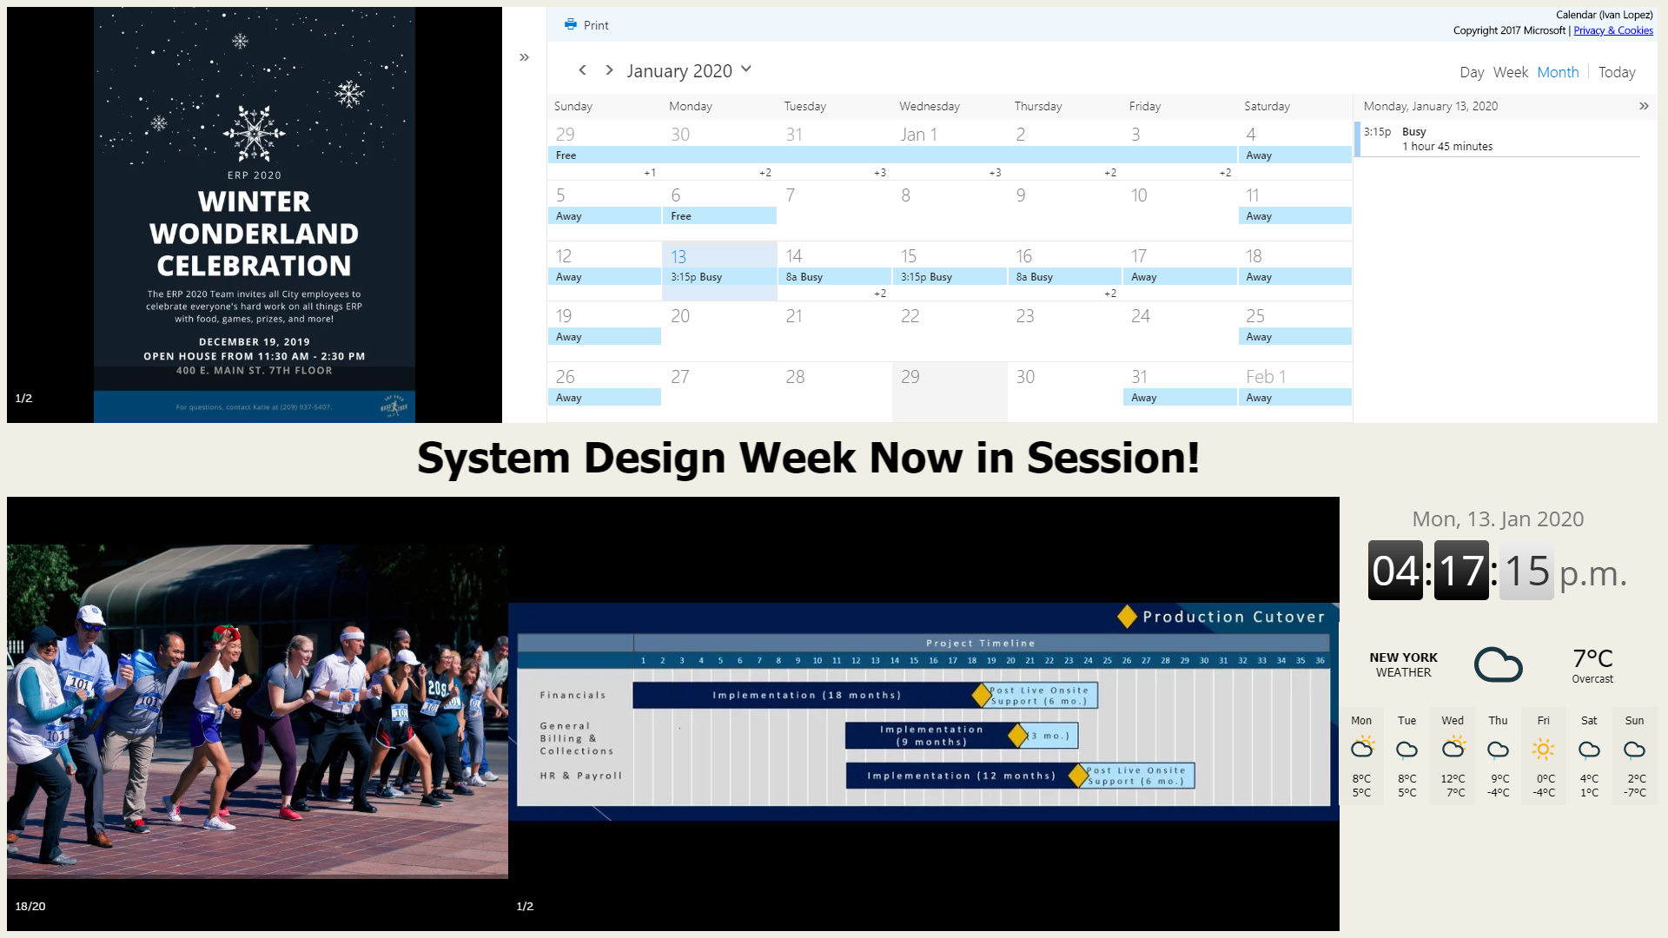

Figure 1 - Dashboard Draft 1

and ERP_Dashboard_Draft_2

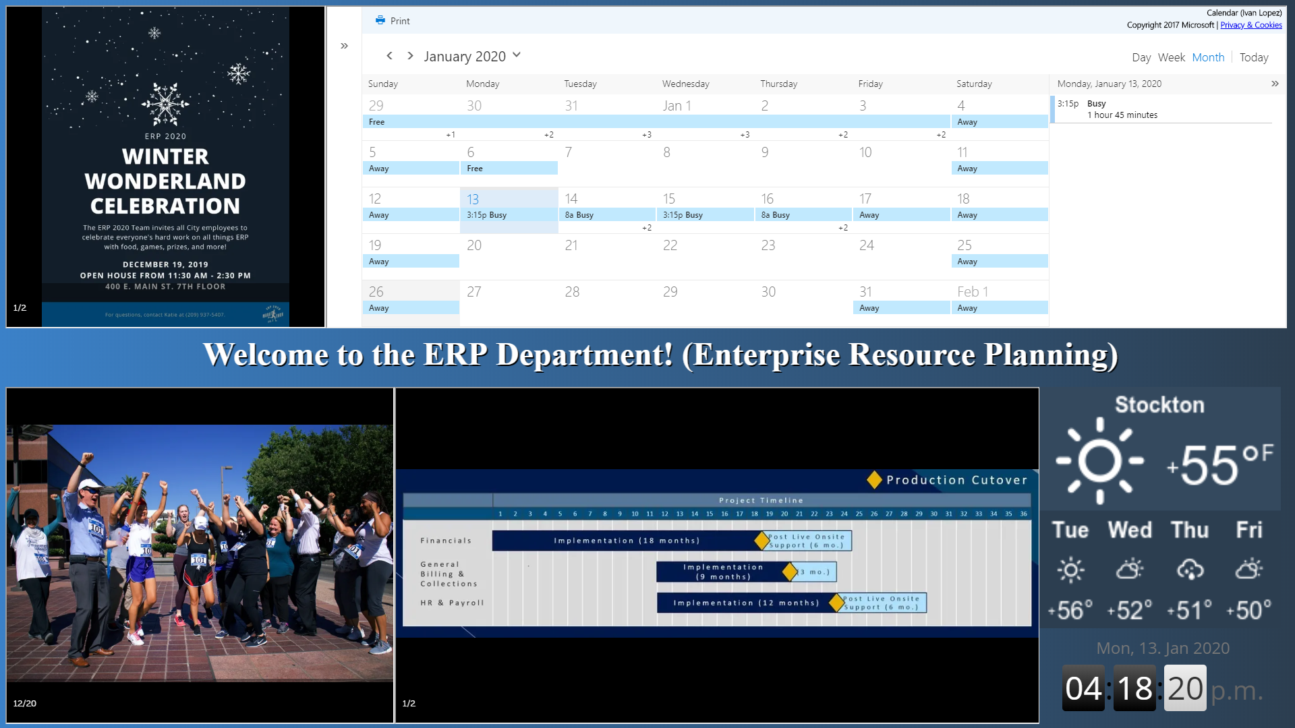

Figure 2 - Dashboard Draft 2

1. **Content Breakdown**

Template Differences

The only differences between the two templates are the background color and a few minor design traits (such as the borders around the photo iframes found in draft 2 that are not found in draft 1). The content of both templates are set up in identical places, with the exception of the date and time and the weather plugins (flipped, and the weather plugin is different).

The comprehensive list of information that are currently provided is:

* Outlook Calendar (1)
* flyers/announcements photo gallery (2),
* text announcements (3),
* employee photo gallery (4),
* ERP phases/floor map gallery (5),
* day and time (6), and
* weekly weather (7).



6

7

5

4

3

2

1

The Outlook Calendar Plugin (1)

The Outlook Calendar plugin is a published Outlook Calendar that is displayed by an iframe.

To publish a calendar from Outlook,

1. make sure that you have full publishing privileges, otherwise the calendar will either not be available to be published or will only show limited information.
2. Then, follow these steps to publish the calendar: [how to publish Outlook calendar](https://www.howtogeek.com/436647/how-to-publish-your-outlook-calendar-from-outlook.com/).
3. Retrieve the HTML link and add it to the dashboard webpage HTML code as an iframe src.

Photo Galleries (2,4-5)

The photo gallery segments are iframes that utilize an online software called photobucket (the link to the website is [here](https://photobucket.com/)). Currently, a free account is being used where a maximum of 250 photos can be stored in the database.

**How to manage photobucket**

There are three albums in the account, one for each gallery (2,4, and 5), Announcements-Flyers, ERP, and Maps-Stages. The slideshow that Photobucket will provide will be made up of photos in an album.

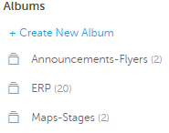

Figure 3 - Photobucket Albums

**To add photos to an album,** enter the wanted folder and drag any photos into the “click to upload” box.

**To remove photos from an album,** select one or more photos in the folder and select the delete button.



Figure 4 - Upload Box and Existing Photos

(A title and description can be added to individual photos)

**How to add the Photobucket albums as iframes in the Dashboard**

On the “SHARE THIS ALBUM” in the right hand side of the album, copy the HTML Embed link and paste it into an iframe tag’s src in the Dashboard’s HTML code.

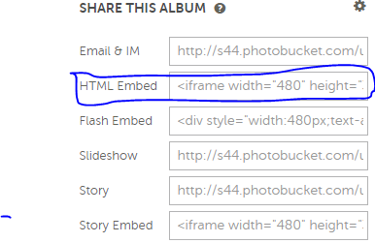

Figure 5 - HTML Embed Slideshow

Text Announcements

­This segment of the Dashboard functions just like the text slide at the bottom of every news show broadcast.

A text editor called TinyMCE is used so an admin can in real-time edit the text in the Dashboard’s slide.

The Javascript code that is used to embed TinyMCE is below:

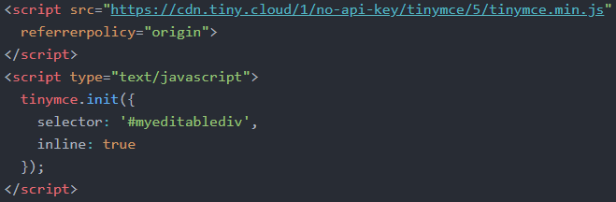

Day and Time

This feature is an iframe clock widget showing the current day and time made available by [www.zeitverschiebung.net](http://www.zeitverschiebung.net).

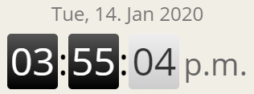

Figure 6 - Day and Time Widget

Weather

This feature is an iframe weather widget showing the current weather and the weather for the rest of the week made available by w.bookcdn.com.

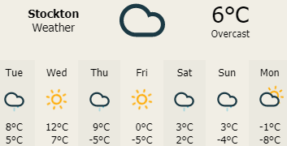

Figure 7 - Weather Widget

**3. Code**

Files

There are 5 total files:

* favicon.ivo (the favicon for the ERP Dashboard website)
* ERP_Dashboard_Draft_1.html (the first template)
* ERP_Dashboard_Draft_2.html (the second template)
* Style_1.css (the style sheet for the first template)
* Style_2.css (the style sheet for the second template)

1. **Repository**

The code has been stored in a GitHub repository: <https://github.com/CF-Dashboard/erp_dashboard>. If there is any trouble accessing it, or if you need administrative access, contact [johnskim97@gmail.com](mailto:johnskim97@gmail.com) or [ivan.lopezamaral@gmail.com](mailto:ivan.lopezamaral@gmail.com).

1. **Future Aspirations for the Dashboard**

There are a lot of possibilities for the Dashboard. Our hope is that this baseline serves as a starting point to developing a great application. Some of the functionality that we were yet to implement and had hoped to incorporate are:

1. The outlook iframe synchronizes with the ERP calendar
2. Map has touch capabilities that will display a short video walking them from “You are here” to their chosen room.
3. ERP makes a photobucket account and synchronizes it to the provided iframe section, separated by folders.